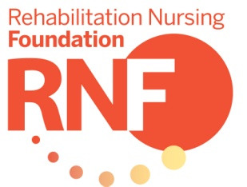

Research
Grant Checklist

Principal Investigator

Title of Proposal

Enclosed Criteria for ALL Research Received

Research Grant Checklist ________
Summary Data Form ________
Administrative Approval Form ________
Abstract Form ________
Research Grant Proposal ________
Should include:
- Statement of the Problem
- Methodology
- References
- Project Budget
- Personnel
- Setting
- Review and Approval
For detailed information and instructions for each section, please see Guidelines for Proposals.

Appendices (include the following for Research Grants) ________
- Measurement Instruments
- Institutional Review Board Approval
- Participant Consent Forms
- NIH Biosketches and Other Supporting Documents

Email Proposals by March 1st (Noon Central Time) to:

Rehabilitation Nursing Foundation
Email: info@rehabnurse.org

Rehabilitation Nursing Foundation
Summary Data Form

Title of Proposal

Name and credentials of Principal Investigator

Amount of funding requested

If awarded, grant funds should be dispersed to:

Institution or Agency Individual Researcher
Federal Id # Social Security #

Please check the check box to indicate your preferred mailing address (home or place of employment).

Home Address

City State Zip Code

Home Telephone Number

Place of Employment

Address

City State Zip Code

Work Telephone Number

Preferred Email Address

Professional Title

Licensed registered nurse numbers and states

Institution where research will be conducted

Address

Name and title of administrative officer of the institution

Institution Telephone Number

Name and credentials of co-investigator(s) if applicable

Rehabilitation Nursing Foundation
Administrative Approval Form

Dear Administrator:

The individual named below plans to submit a Research grant proposal to the Rehabilitation Nursing Foundation with the intent of securing a nursing research grant. The Rehabilitation Nursing Foundation (RNF) is the research and development foundation of the Association of Rehabilitation Nurses.

The RNF Board of Trustees requests your signature as an administrator of the institution or agency in which the Principal Investigator is employed. Your signature indicates that the conduction of this research by your employee, if granted RNF funding, is approved by your institution or agency. Thank you for your time and your support of this worthwhile study. Please return this form to the Principal Investigator, who will enclose it with other application materials.

Sincerely,
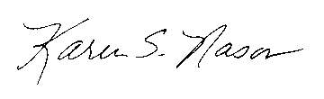
Karen S. Nason
Executive Director

Name of Principal Investigator

Title of Proposal

Name of institution or agency at which the PI is employed

Signature of administrative officer of the institution

Title Date

Return this form to the Principal Investigator for inclusion in the proposal packet.

Rehabilitation Nursing Foundation
Abstract Form

In 250-350 words, define the research question, state the significance of the research project, and present the research methodology and plan for analysis.
DO NOT USE A SEPARATE SHEET.

