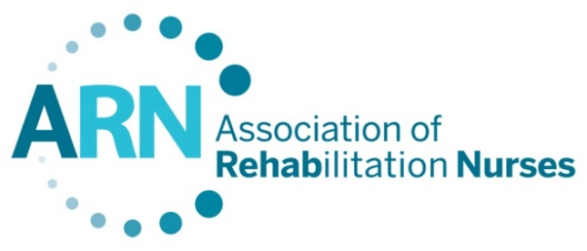
ARN Supports Increased FY 2024 Funding for the Traumatic Brain Injury Act
The Association of Rehabilitation Nurses (ARN) is a professional nursing organization representing more than 4,500 rehabilitation nurses and more than 14,000 certified rehabilitation registered nurses (CRRN). ARN promotes and advances professional rehabilitation nursing practice through education, advocacy, collaboration, and research to enhance quality of life for those affected by disability and chronic illness.
Traumatic Brain Injury Act
According to the Brain Injury Association of America, 2.8 million people sustain a traumatic brain injury (TBI) each year. It is estimated that the annual national cost of providing treatment and services for these patients is $82 billion in direct care and lost workplace productivity. Continued fiscal support of the Traumatic Brain Injury Act will provide the funding needed to develop research and improve the lives of individuals who suffer from traumatic brain injury.
The TBI Act promotes sound public policy in brain injury prevention, research, education, treatment, and community-based services while informing the public of the needed support for individuals living with TBI and their families. With regard to these initiatives, ARN requests that the following programs within this statute receive the maximum possible funding:
- The Centers for Disease Control and Prevention (CDC) TBI Registries and Surveillance, Prevention and National Public Education/Awareness;
- The Health Resources and Services Administration (HRSA) Federal TBI State Grant Program; and
- The HRSA Federal TBI Protection and Advocacy (P&A) Systems Grant Program.

ARN strongly supports the work being done by the CDC and HRSA to improve understanding of traumatic brain injury and the provision of care to individuals affected by TBI.
Recommendation: ARN continues to recommend $19 million in FY 2024 for the Federal TBI State Grant Program, $6 million to the P&A Grant Programs and $11.7 million to fund the CDC’s TBI Programs.
If you have additional questions about these issues please contact ARN’s Health Policy Associate, Jeremy Scott (202/872-6734 or jscott@dc-crd.com).

Retrieved on February 26, 2019 from https://www.biausa.org/downloads/public-affairs/Public%20Policy/2019%20Legislative%20Issue%20Briefs.pdf

